**Hash Tables**

Hash tables are Objects that contain a key/value pair.

key = nails

value = 1000

{

    nails: 1000

}

When we hash this Object, only the key will be hashed (nails) and placed into a table.

Example: when we hash nails, it would give us an address of 2 which is where we will place that object in our memory.

If we wanted to look up the value of nails, we could go directly to the address of 2 which is very efficient.

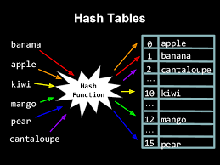

Hash tables are one way only meaning that we can hash nails and get the number 2 but we cannot hash 2 to get nails.

Hash tables are also deterministic meaning that when we hash nails and get 2, the next time we hash nails, it will produce 2 as well.

set('nails', 1000)

get('nails')

Since we are hashing the same string ‘nails’, it does not matter what method we are using, either set, get, etc. we will always hash them into the same address which is in this example ‘2’.

******************************************************************************************************

**Collisions**

Collisions are when there is more than one item mapped to the same address in memory.

**Separate Chaining**

This is when we have more than one item in an address space.

**Linked List in Separate Chaining** – we can implement a linked list in the address space so that more than one item can be mapped to the address.

**Linear Probing (type of Open Addressing)**

When the item is mapped to an address space and the space is already occupied, then it will move to the next address space until it finds a space that is empty then occupies it.

******************************************************************************************************

Prime numbers are used for optimal randomized distribution of the items you place in hash tables.